SQL_Assignments_Set_8

1. Produce the following output only using Window Functions:

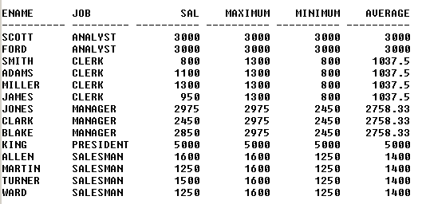

**select ENAME, JOB, SAL, MAX(SAL) over(partition by Job) , MIN(SAL) over(partition by Job), AVG(CAST(SAL as FLOAT)) over(partition by Job)**

**from emp**

1. Produce the following output only using Window Functions:

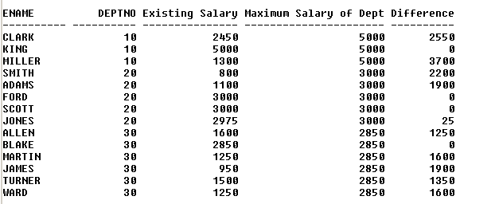

**select ENAME, DEPTNO, sal "Existing Salary", max(sal) over (partition by deptno) "Max Salary of Dept",**

**(max(sal) over(partition by deptno) - sal) "Difference"**

**from emp**

**order by DEPTNO**

1. Display only the second highest salary employee (s) record (s) in each job type using Windows functions.

**with JobWise_Rank as(**

**select *, dense_rank() over(Partition by job order by SAL DESC) as "EMP_RANK"**

**from emp)**

**select * from JobWise_Rank**

**where EMP_RANK = 2**

1. Display the record (s) of employee (s) having the oldest hiring date in their respective job type using Windows function.

**with HireDate_RANK as(**

**select *, dense_rank() over(Partition by job order by hiredate) as "Rank"**

**from emp)**

**select * from HireDate_RANK**

**where Rank = 1**

1. Display the highest earner (s) records in each deptno using Windows function.

**with DeptWise_Rank as(**

**select ename, Sal, Deptno, dense_rank() over(Partition by deptno order by SAL DESC) as "EMP_RANK"**

**from emp)**

**select * from DeptWise_Rank**

**where EMP_RANK = 1**